Clusterer Manual
By Ivica Ceraj

Introduction 2
What is Clusterer? 2
Where can I find out more about Clusterer? 2
How much it costs to purchase Clusterer? 2
Introduction 3
Run as an applet 3
Run as an Web Start application 3
Run as an Application 3
Troubleshooting 3
Using the application 4
Accepting license terms 4
About project 4
Selecting type of analysis 5
Analysis that starts by importing sequences 6
Importing sequences 6
Selecting file format 6
Customizing import process 7
Building distance matrix 7
Reviewing and exporting distance matrix 7
Analysis that starts by importing distance matrix 10
Importing distance matrix 10
Cluster analysis 10
Introduction 10
Results 11
Rarefaction curve 13
Cluster summary 15
Introduction and results 15
Cluster image 15
Developer information 16
How to include new file format for sequence import? 16
How to include new distance matrix generation algorithm? 16
How to include new clustering algorithm? 16

Introduction

What is Clusterer?
Clusterer is an extendable java application that groups sequences into clusters and performs additional analysis on the generated datasets.
Design goals included:
- easy to use user interface
- well defined set of extension points to help extend the application in the future
- concurrent execution of calculations to encourage users to experiment with parameters

Where can I find out more about Clusterer?
In bioinformatics note [insert quote here].

How much it costs to purchase Clusterer?
Clusterer is free of charge. Its source code is released via Open Source compliant license. We only require that any results or derivative work must cite bioinformatics note describing the application.
Setup

Introduction
Clusterer can be invoked in 3 ways, to get users started as quickly as possible, while at the same time allowing advanced users or developers the freedom to extend the application.

Run as an applet
User can click on “Start clusterer as an applet” on the Clusterer homepage assuming user’s browser supports execution of applets using Sun Java 1.4 or newer.

Run as an Web Start application
User can click on “Start clusterer as a Web Start application” on the Clusterer homepage; assuming user’s browser has mapping to Java Web Start using Sun Java 1.4 or newer, a small file will download and Clusterer will start as Java Web Start application.

Run as an Application
Running Clusterer as application is only recommended if you are planning to extend the application. To run clusterer as an application, please download source code from the Clusterer homepage by clicking on “Download sources” link, and extract source code. Please use Java Development Kit (JDK) 1.4 on newer to re-compile and execute source.

Troubleshooting
If you have problems starting an application, please refer to frequently asked question section of the web site, by clicking on “View FAQ”.

Using the application

Accepting license terms
When application is started, the user is prompted to accept license terms:

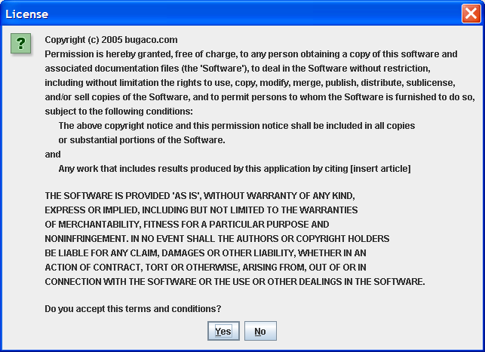

Users can start the application only upon accepting license terms. If unwilling to accept these terms the application will terminate.

About project
This section informs users about recent updates to the project and provides links to this manual. It also informs the user how to request a feature or to submit a bug related to the project.

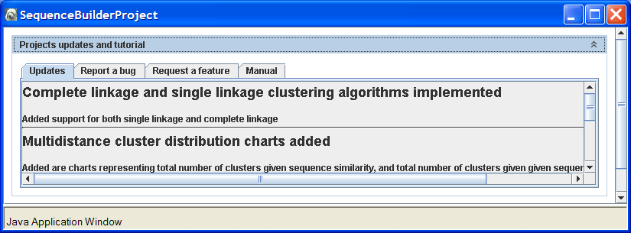

Selecting type of analysis
Users can select one of two types of analysis. An analysis that will start by importing aligned sequences in NEXUS or Fasta format, or that will start by importing distance matrix values stored as CSV file.

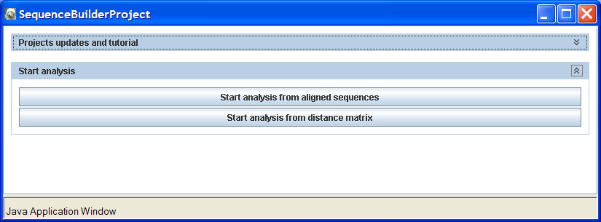

Analysis that starts by importing sequences

Importing sequences
Importing sequences can start by pasting the content of Fasta or NEXUS file in text area, or by clicking on the Import file button. If Clusterer is invoked as a Web Start application, a security advisor dialog box will prompt users to allow access to a file from the local file system.

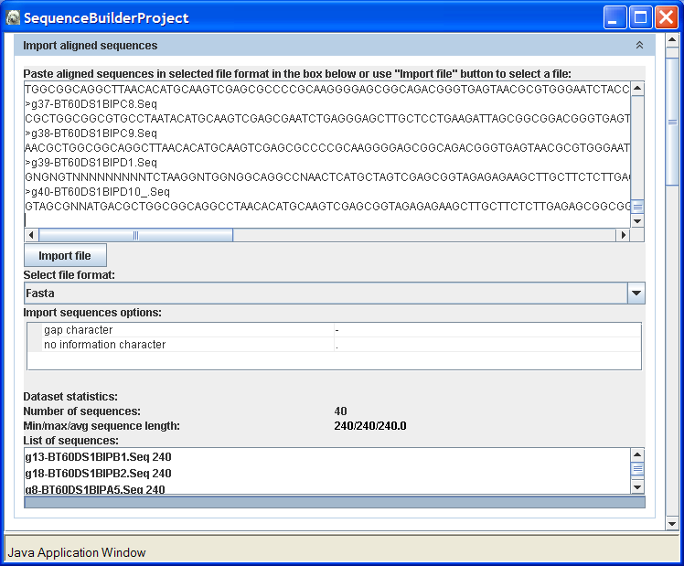

If users choose to allow access to local file system, users will be prompted to navigate to a file whose content will be loaded into the text area.

Note: “Import file” button does not work if Clusterer is invoked as applet.

Selecting file format
Currently two file formats are supported, Nexus and Fasta. Users can choose file format from the “Select file format” list. Text area will be reloaded upon change in selection.

Customizing import process
Both Nexus and Fasta file parsers support customization of gap character (by default minus sign) and no information character (by default a dot).

Building distance matrix
A distance matrix is built from the imported sequence set. Users have the ability to select an algorithm and parameterize the algorithm.
The application comes with a built-in algorithm, which calculates a distance matrix by counting the number of base-pair differences, where two base-pairs are assumed equal if they could be represented by the same nucleotide according to UIPAC nomenclature. Gap character and no information character weights can be customized in the calculation of the distance.

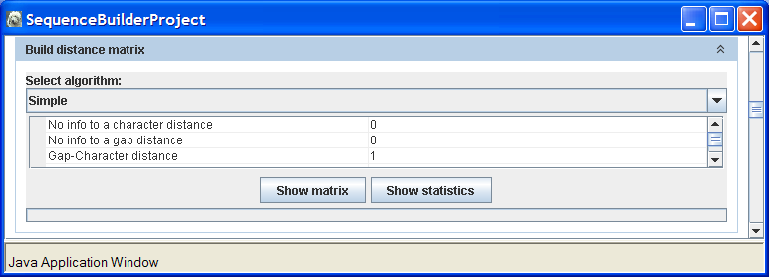

Reviewing and exporting distance matrix
The distance matrix can be reviewed by clicking on the “Show matrix” button. A new dialog presents a spreadsheet with names of the sequences and distances in absolute number of base-pair differences. Users can either copy the content to a clipboard, save the matrix as a file, or close the dialog.
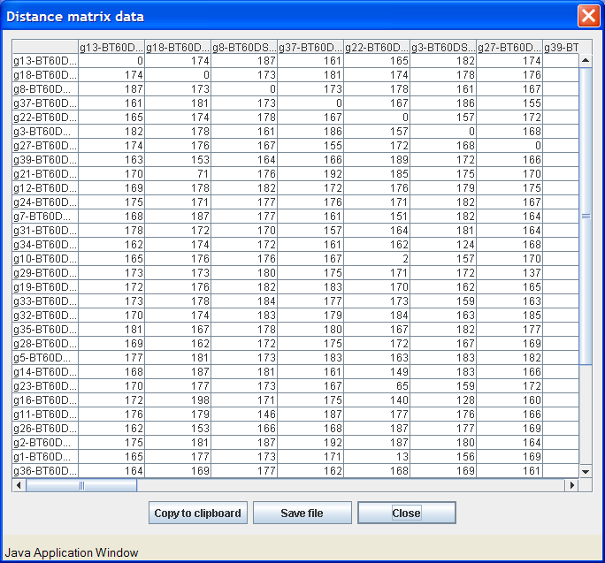

Note: While executing as an applet, due to security restriction it may not be possible to perform copy or save functions from this or any other review data dialog boxes.

It is also possible to review some statistics pertaining to the distance matrix by opening the “Show statistics” dialog. This dialog provides users with information about minimal, maximal and average values found in distance matrix, and it displays the distribution of distances between sequences pairs.
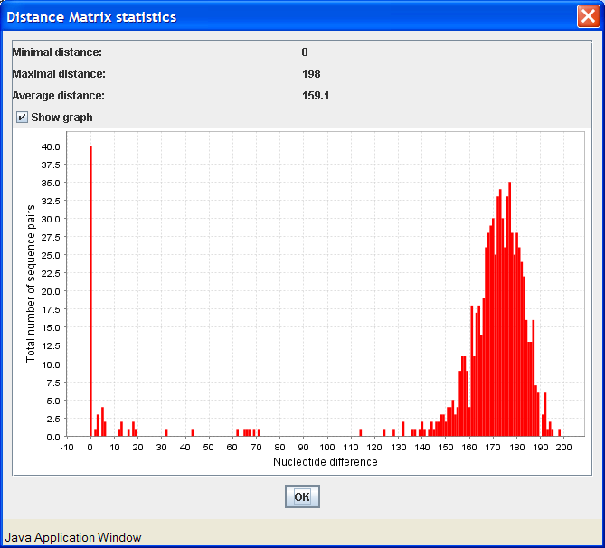

Analysis that starts by importing distance matrix

Importing distance matrix
User can start the analysis by loading a distance matrix generated by some other application. Clusterer has a built-in algorithm for reading distance matrices from comma separated values (CSV) files. The box below the file format is empty as this import algorithm does not have any parameters that can be modified. If another algorithm, which allows for parameterization, is implemented, this space would contain the list of parameters.
By pressing on the show matrix button, a dialog box similar to the “Reviewing and exporting distance matrix” in the previous chapter will appear, allowing visual inspection of the distance matrix.
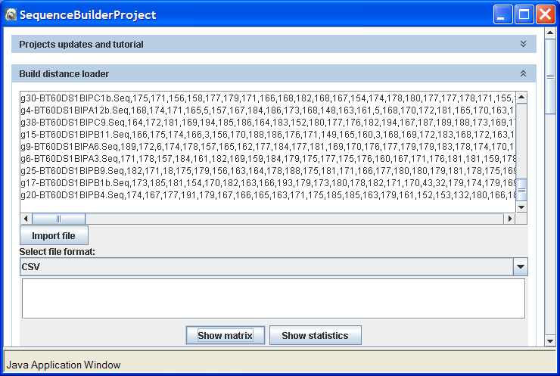

Cluster analysis

Introduction
Cluster analysis is a common module in Clusterer. It generates clusters using a distance matrix as its input.
Clusters are generated by first selecting a clustering algorithm. Clusterer comes with 2 built-in algorithms: complete linkage and single linkage. More information about clustering algorithms is provided in Sneath and Sokal (1973).
User can choose to review clusters for different distance cut-offs. For each selected distance all tabs update with appropriate information.

Results
The cluster grouping overview tab displays clusters in form of a tree, nodes can be expanded to explore which sequence fall in each cluster for a given cut-off level. Data can be exported by clicking on the “Show data” button. Data are presented in CSV format and can be copied to the clipboard or saved to a file.
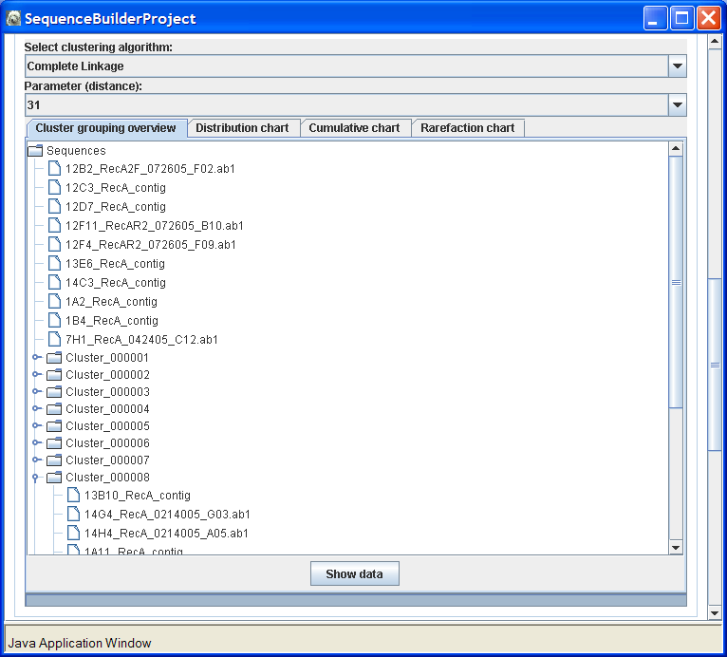

The distribution chart plots cluster size vs. number of clusters. Data points in the chart can be reviewed by using the “Show data” button. Data points can be exported and re-drawn using other graphical tools to create publication quality images.

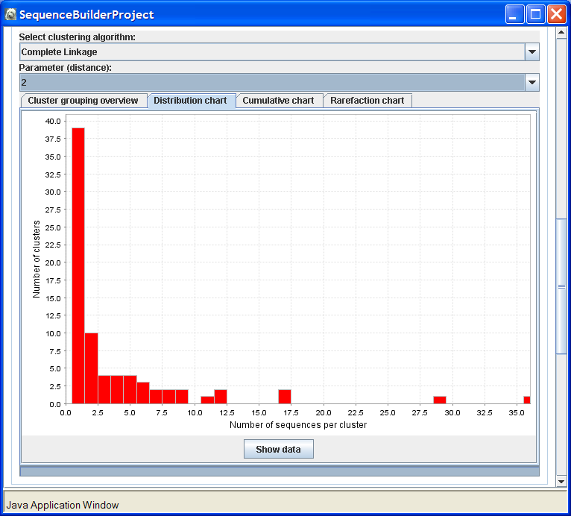
The cumulative chart tab presents cluster sizes vs. cumulative number of sequences. Data can be exported using the “Show data” dialog.

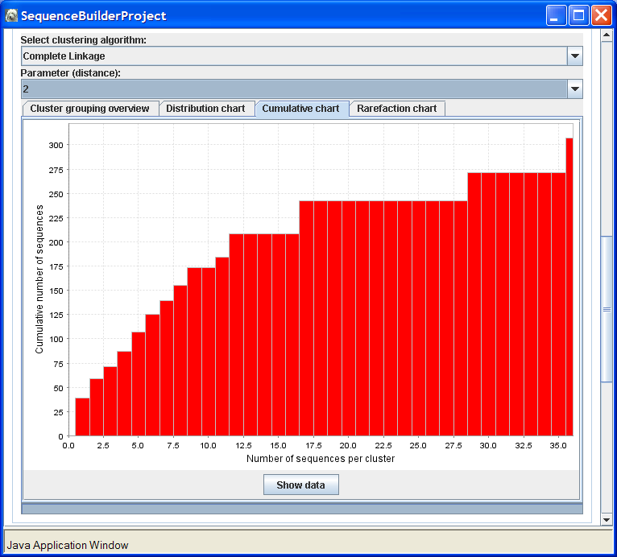

Rarefaction curve
Rarefaction analysis is an important feature added to Clusterer and is implemented using existing rarefaction code (http://www2.biology.ualberta.ca/jbrzusto/rarefact.php). Due to the computational intensity of this analysis, it needs to be initiated manually by clicking on the “Calculate” button. The analysis uses cluster distribution as input to generate rarefaction curves that are used to estimate completeness of data sampling. Data can be exported using the “Show data” dialog.
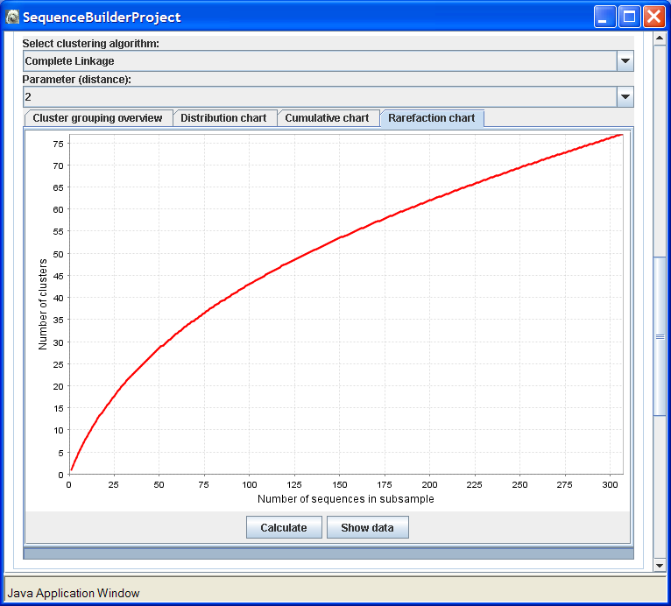

Cluster summary

Introduction and results
The cluster summary module presents results calculated in the previous module by combining data at all distance cut-off levels. In the similarity chart tab similarity vs. total number of clusters are presented, and the distribution chart distance vs. total number of clusters visualizes diversity at different cut-off levels. Data charts can be exported using the “Show data” dialog, and analyzed external to the Clusterer package.

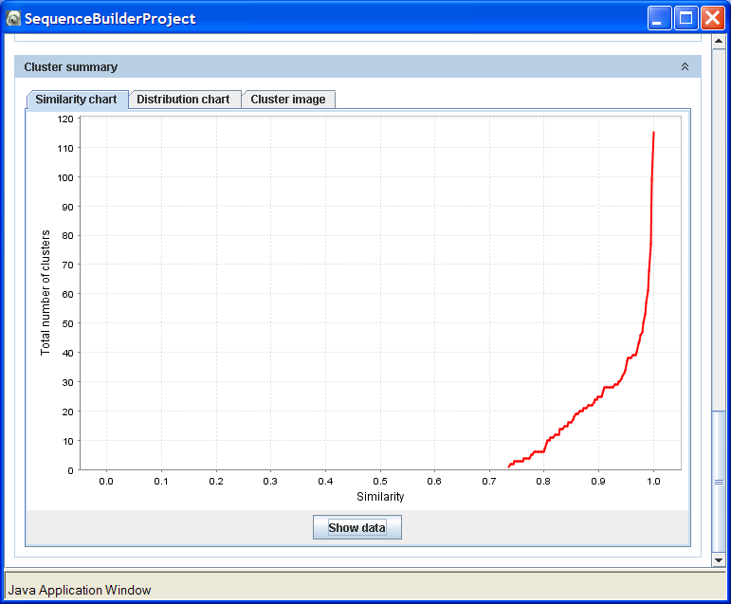

Cluster image
Clusterer image is a two dimensional chart where each point corresponds to one of the following states:
- even numbered sequence not in cluster – gray
- odd numbered sequence not in cluster – pink
- sequence in cluster – red
This chart visualizes the structure of similarity for the sequence set and displays when sequences start to combine in the clusters.
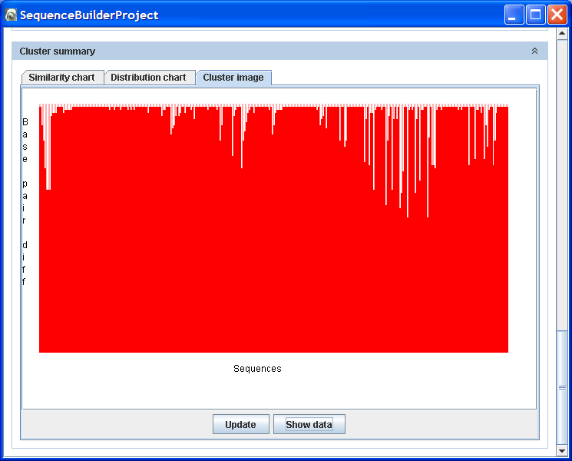

Developer information

How to include new file format for sequence import?
Add class name and label to /conf/SequenceImporters.properties.
Classes need to implement com.bugaco.mioritic.model.module.algorithm.rawcompiler.*

How to include new distance matrix generation algorithm?
Add class name and label to /conf/DistanceCompiler.properties.
Classes need to implement com.bugaco.mioritic.model.module.algorithm.distancematrix.*

How to include new clustering algorithm?
Add class name and label to /conf/ClusterCompiler.properties.
Classes need to implement com.bugaco.mioritic.model.module.algorithm.clustering.*

